**DAILY ONLINE ACTIVITIES SUMMARY**

|  |  |  |  |  |
| --- | --- | --- | --- | --- |
| **Date:** | **27-06-2020** | | **Name:** | **Shetty Disha Ravindra** |
| **Sem & Sec** | **VI B sec** | | **USN:** | **4a17cs087** |
| **Status:executed** | | | | |
| **Uploaded the report in Github** | | **Yes** | | |
| **If yes Repository name** | | **Disha_Shetty** | | |
| **Uploaded the report in slack** | | **Yes** | | |
| **PYTHON ASSIGNMENT PROGRAM**  **1]  Python Program to Find the Area of a Rectangle Using Classes** Screenshot (91).png | | | | |

DBMS Assessment

1-

Student (snum: integer, sname: string, major: string, level: string,age: integer)  
Class (name: string, meets at: string, room: string, d: integer)  
Enrolled (snum: integer, cname: string)  
Faculty (fid: integer, fname: string, deptid: integer)

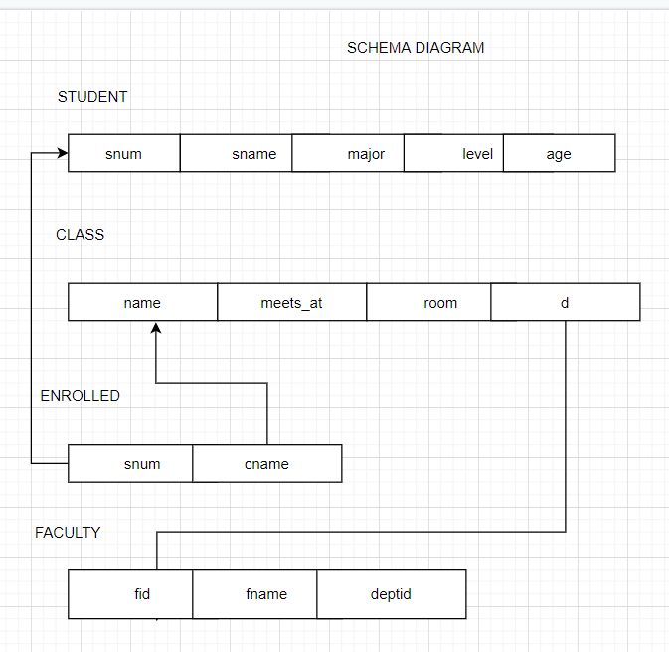

2-

BRANCH(branch-name:string,branch-city:string,assets:real)  
ACCOUNT(accno:int,branch-name:string,balance:real)  
DEPOSITOR(customer-name:string,accno:int)  
CUSTOMER(customer-name:string,customer-street:string,city:string)

